A Minor Project Proposal on

**LAYE**

Submitted in partial fulfilment of the requirements for the degree of

Bachelor of Engineering in Software Engineering at Pokhara University

***By***

**ARJUN ADHIKARI**

**BIPINADHIKARI**

**NARAYAN ACHARYA**



**Department of Research and Development**

**GANDAKI COLLEGE OF ENGINEERING AND SCIENCE**

Lamachaur, Kaski, Nepal

**June, 2022**

A Minor Project Proposal on

**LAYE**

Submitted in partial fulfilment of the requirements for the degree of

Bachelor of Engineering in Software Engineering at Pokhara University

***By***

**ARJUN ADHIKARI**

**BIPINADHIKARI**

**NARAYAN ACHARYA**

***Supervisor***

**Er. Ishwor Thapa**



**Department of Research and Development**

**GANDAKI COLLEGE OF ENGINEERING AND SCIENCE**

Lamachaur, Kaski, Nepal

**June, 2022**

# **APPROVAL CERTIFICATE**

This project entitled "**Laye**" prepared and submitted by **Arjun Adhikari, Bipin Adhikari and Narayan Acharya** under the supervision of "**Er. Ishwor Thapa**" in partial fulfilment of the requirements for the Degree of Bachelor of Engineering in Software Engineering has been examined and is recommended for approval and acceptance.

**Date of Evaluation:** May 30, 2022

**……………………………………**

**Er. Ishwor Thapa**

(Project Supervisor)

**…………………………………**

**Er. Rajendra Bahadur Thapa**

(Acting Coordinator)

**Research Management Committee**

**Gandaki College of Engineering and Science**

# **ABSTRACT**

The music industry has undergone major changes in production, distribution and consumption habits due to breakthroughs in new technologies, especially streaming platforms. “Laye” is a music streaming app where one can search, play and download music, podcasts or even audiobooks from different artists. Logging in into this app lets you do all these above activities. However, users not registered are able to play music but will not be able to make playlists and add songs to their favourites.

**TABLE OF CONTENTS**

APPROVAL CERTIFICATE iii

ABSTRACT iv

Chapter 1 1

INTRODUCTION 1

1.1. BACKGROUND 1

1.1. PROBLEM STATEMENT 1

1.2. OBJECTIVES 1

1.3 IMPLICATIONS 2

Chapter 2 3

LITERATURE REVIEW 3

1. Spotify 3

2. Deezer 3

3. Gaana 3

TOOLS AND METHODOLOGY 5

3.1. REQUIRED TOOLS 5

3.2. APPROACH USED 5

3.3. DESIGNS 7

3.3.1. USE CASE DIAGRAM 7

3.3.2. ENTITY RELATIONSHIP DIAGRAM 8

3.3.3 SEQUENCE DIAGRAM 9

CHAPTER 4 10

TIMELINE CHART 10

WIREFRAMES 11

Bibliography 15

[LIST OF TABLES](https://docs.google.com/document/d/1tbVZHWxrCDsD_yvd2SR4LommIgCo209Ef0LIToj33yU/edit#heading=h.3as4poj)

TABLE 2.1: TABLE OF COMPARISON 4

TABLE 5.1: PROJECT TIMELINE 10

**LIST OF FIGURES**

FIGURE 3.2.1: AGILE MODELS 6

FIGURE 3.3.1: USE CASE DIAGRAM 7

FIGURE 3.3.2: ENTITY-RELATIONSHIP DIAGRAM. 8

FIGURE 3.3.3: SEQUENCE DIAGRAM. 9

FIGURE 4.1: TIMELINE CHART 10

FIGURE 5.1: HOME PAGE. 11

FIGURE 5.2: ARTIST'S PROFILE. 12

FIGURE 5.3: LOGIN PAGE. 13

FIGURE 5.4: MUSIC PLAYER. 14

# **Chapter 1**

# **INTRODUCTION**

## **BACKGROUND**

Since the beginning of the oldest societies, music has played a fundamental role in the life of human beings, being undeniably a form of universal expression that unites old and future generations culturally and emotionally. The music industry has undergone major changes in production, distribution and consumption habits due to breakthroughs in new technologies, especially streaming platforms. Due to the fact that sales of physical copies continue to decline significantly, it was imperative for the industry to reform itself by adopting music streaming services as an important part of business development.

The purpose of this project is to understand the factors that influence music consumption through streaming platforms, especially the intent to introduce and recommend different versions of music streaming services.\

## **PROBLEM STATEMENT**

* Artists have started releasing their creations online instead of physical albums and cassettes.
* Carrying a music player and music albums may not be convenient.
* Searching & buying desired albums in stores is time-consuming and difficult.
* Limited life-span and insecurity of the physical albums.
* Lack of a reliable music streaming platform in Nepal.

## **OBJECTIVES**

The main objective of this project is to develop an app where one can search, download and play desired albums and songs online including audiobooks and podcasts from various artists and creators. The other intended goals of this project are as follows:

* To provide a reliable platform for emerging artists and creators to release their musical creations.
* To fulfil the deficit of reliable music publishing for creators.
* To make Nepali music easily accessible to the audience.

## **IMPLICATIONS**

People are listening to more music now, from more artists than ever before because of streaming services and their prevalence. Music streaming apps make it easy for us as consumers to pick and choose what we want to listen to. Consumers can now tap on a song and hear it instantly, instead of being limited to only listening to the album they just bought. “Laye” is a free online music streaming application. This app is mainly targeted to the people who are melomaniac. It can come handy to all users as they can access music, audiobooks and podcasts easily. This app also provides a platform for the registered artis and creators to release their creations. Moreover, registered users have the ability to make playlists for them and can even download songs for them to listen to while being offline.

# **Chapter 2**

# **LITERATURE REVIEW**

## **1. Spotify**

Spotify is a Swedish music streaming company founded in 2008 by Daniel Ek and Martin Lorentzon. The service is currently available in 58 countries, has 75 million users and 20 million paying subscribers. Spotify’s mission is to bring you the right music at every moment through its features and platforms. The company offers two tiers. The free tier has a shuffle licence and is supported by advertising. The paid tier has on-demand access to the full music catalogue and offline functionality among other benefits. The core functionality in Spotify is being able to play, save and organise artists, albums and tracks. Spotify is available on desktop, web, mobile, tablet and TV. Through partnerships the service is also integrated into a range of home entertainment systems.

## **2. Deezer**

Deezer is a French online music streaming service. It allows users to listen to music content from record labels, as well as podcasts on various devices online or offline. This app gives you access to over 90 million tracks worldwide and other audio content like podcasts. Deezer is part-owned by two companies, Access Industries and Rotana Group, who both own record companies (Access is the 100% owner of Warner Music Group).

## **3. Gaana**

Gaana is [India](https://en.wikipedia.org/wiki/India)'s largest commercial [music streaming](https://en.wikipedia.org/wiki/Music_streaming) service with over 200 million monthly users. It was launched in April 2010 by [Times Internet](https://en.wikipedia.org/wiki/Times_Internet) and provides both Indian and international music content. The entire [Indian music](https://en.wikipedia.org/wiki/Music_of_India) catalogue is available to users worldwide. Gaana features music from 21 Indian languages including the major languages such as [Assamese](https://en.wikipedia.org/wiki/Assamese_language), [Bengali](https://en.wikipedia.org/wiki/Bengali_language), [Bhojpuri](https://en.wikipedia.org/wiki/Bhojpuri_language), [English](https://en.wikipedia.org/wiki/English_language), [Gujarati](https://en.wikipedia.org/wiki/Gujarati_language), [Hindi](https://en.wikipedia.org/wiki/Hindi), [Kannada](https://en.wikipedia.org/wiki/Kannada), [Urdu](https://en.wikipedia.org/wiki/Urdu_language), [Odia](https://en.wikipedia.org/wiki/Odia_language), [Marathi](https://en.wikipedia.org/wiki/Marathi_language), [Punjabi](https://en.wikipedia.org/wiki/Punjabi_language), [Tamil](https://en.wikipedia.org/wiki/Tamil_language), [Telugu](https://en.wikipedia.org/wiki/Telugu_language), [Maithili](https://en.wikipedia.org/wiki/Maithili_language), [Malayalam](https://en.wikipedia.org/wiki/Malayalam) and other Indian regional languages.

Gaana allows users to make their playlists public so that they can be seen by other users. They can view and favourite playlists. Its [mobile app](https://en.wikipedia.org/wiki/Mobile_app) was launched to support almost all popular operating systems like [Android](https://en.wikipedia.org/wiki/Android_(operating_system)), [iOS](https://en.wikipedia.org/wiki/IOS) and [Windows](https://en.wikipedia.org/wiki/Windows_OS). Gaana is priced at ₹99 (US$1.30) per month (within India) or $3.99 per month (outside India). Its free version is also available. Premium version offers Ad-free music, HD quality music streaming and allows users to download songs to play offline.

| **App Features** | **Spotify** | **Deezer** | **Laye** | **Ganna** |
| --- | --- | --- | --- | --- |
| **Search** | YES | YES | YES | YES |
| **Making Playlist** | YES | YES | YES | YES |
| **Free Downloads** | NO | NO | YES | NO |
| **Available in Nepal** | YES | NO | YES | NO(SOME) |
| **Made for audiobook** | NO | NO | YES | NO |

**Table 2.1: Comparison Table**

**Chapter 3**

# **TOOLS AND METHODOLOGY**

## **3.1. REQUIRED TOOLS**

Many tools are required for the development of Laye. Some of the tools that are required in the project are listed below:

1. Visual studio code: For IDE
2. Flutter Framework: For frontend development
3. Node.js: For backend development
4. Google Docs: For preparing proposal and final report
5. Día: For designing UML diagrams
6. MongoDB: For database
7. Git and GitHub: For version control and collaboration

## **3.2. APPROACH USED**

Every software development methodology approach acts as a basis for applying specific frameworks to develop and maintain software. Several software development approaches have been used since the origin of information technology. We will be using the Agile model for development of Laye.

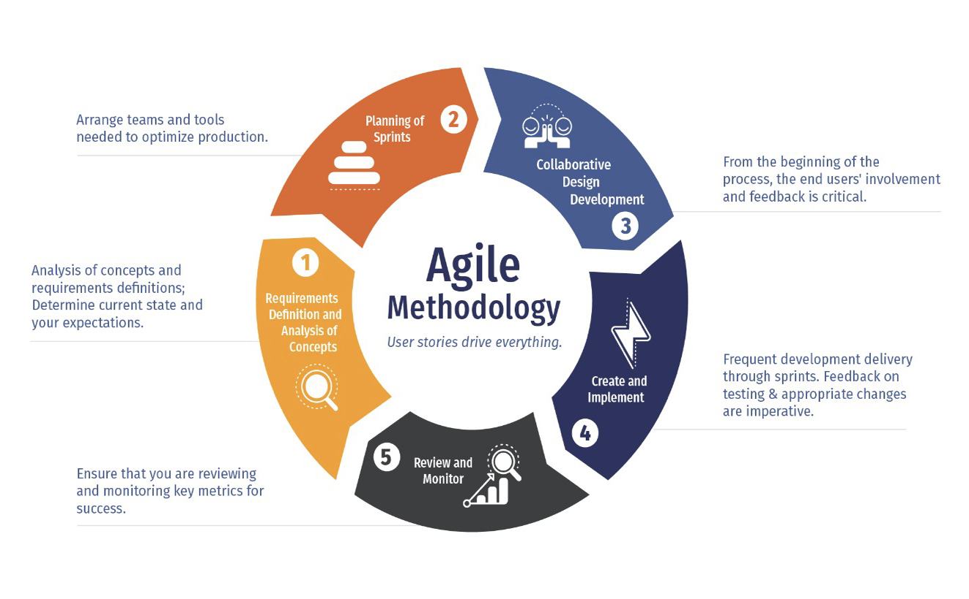

**Fig 3.2.1: Agile Model**

## **3.3. DESIGNS**

### **3.3.1. USE CASE DIAGRAM**

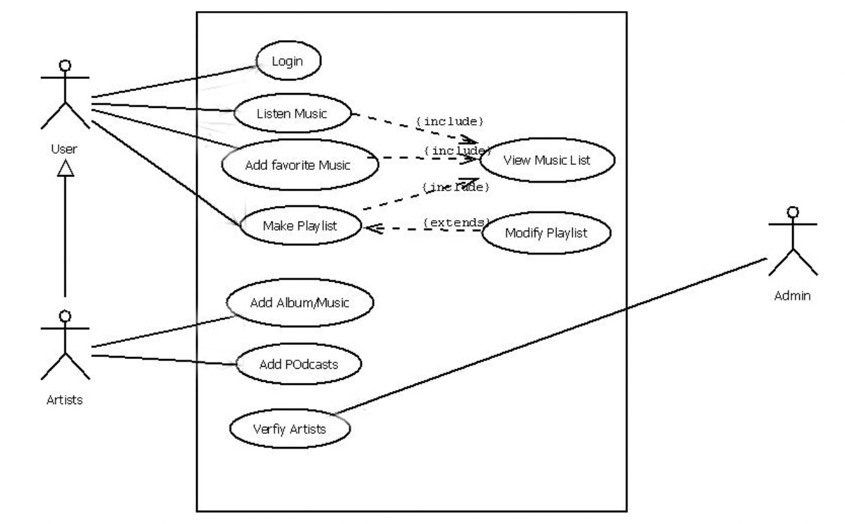

**FIG 3.3.1: Use Case Diagram**

### 

### **3.3.2. ENTITY RELATIONSHIP DIAGRAM**

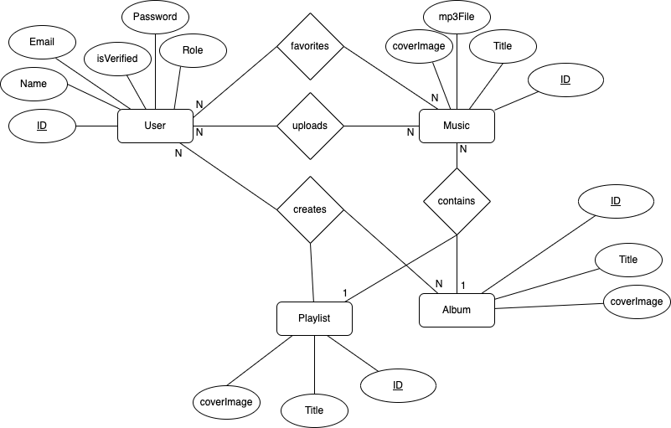

**FIG 3.3.2: Entity Relationship Diagram**

### **3.3.3 SEQUENCE DIAGRAM**

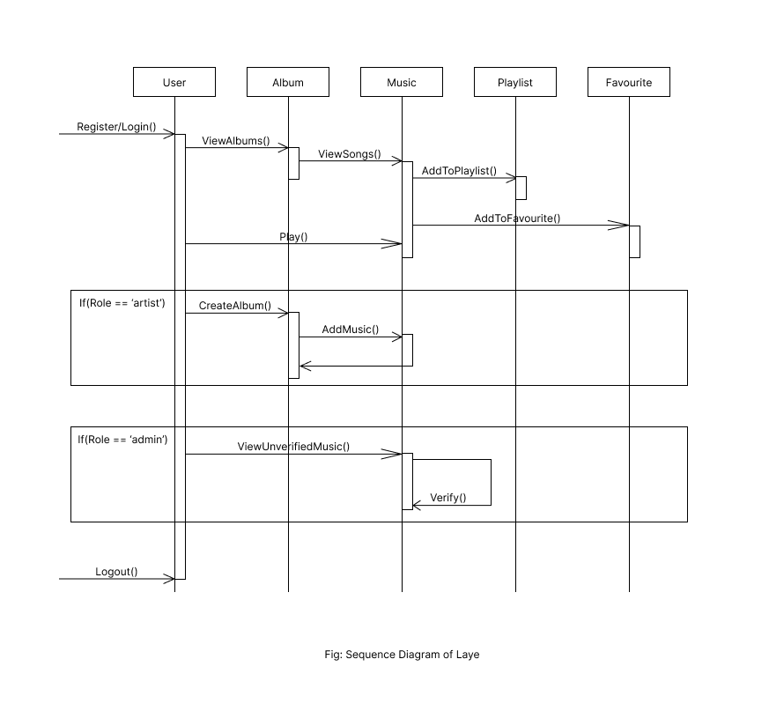

**FIG 3.3.3: Sequence Diagram**

# **CHAPTER 4**

# **TIMELINE CHART**

The project events are scheduled as follows:

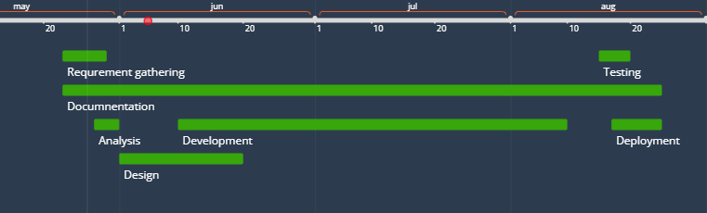

**FIG 4.1: Project Timeline Chart**

|  |  |  |
| --- | --- | --- |
| **Task** | **Date** | **Duration(days)** |
| Analysis | 23 May | 6 |
| Design | 1 June | 18 |
| Development | 10 June | 59 |
| Testing | 15 Aug | 5 |
| Documentation | 23 May | 90 |
| Deployment | 17 Aug | 7 |

**Table 4.1: Project Timeline**

**CHAPTER 5**

# **WIREFRAMES**

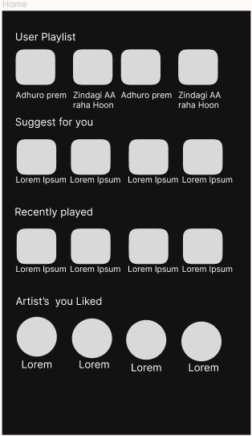

**FIG 5.1: Home Page**

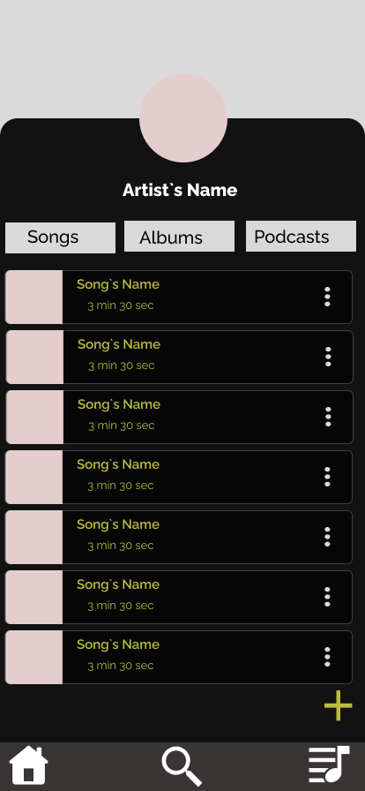

**FIG 5.2: Artist’s Profile Page**

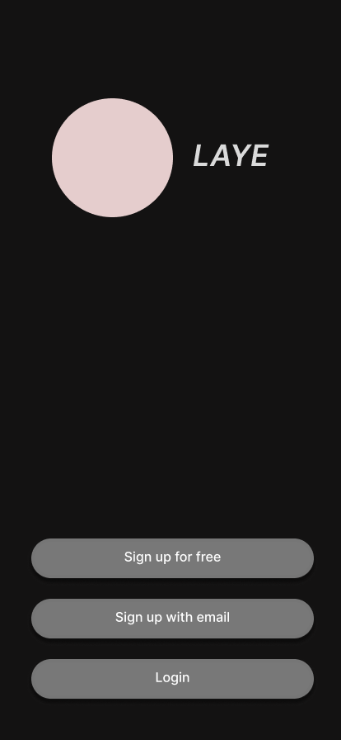

**FIG 5.3: Login Page**

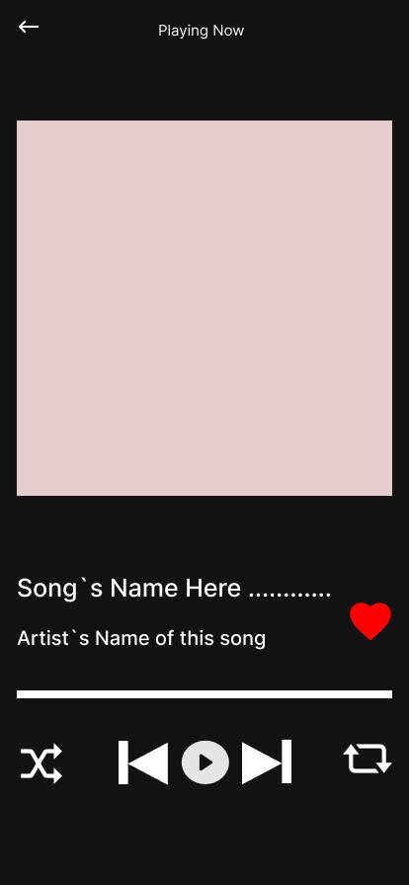

**FIG 5.4: Music Player**

# **Bibliography**

Spotify (2006) ,accessed June 2022, Retrieved from

[*https://www.spotify.com*](https://www.spotify.com)

Gaana (2010),accessed June 2022. Retrieved from

[*https://en.wikipedia.org/wiki/Gaana_(music_streaming_service)*](https://en.wikipedia.org/wiki/Gaana_(music_streaming_service))

Deezer (2007),accessed June 2022. Retrieved from

[*https://www.deezer.com*](https://www.deezer.com)